The list of the Diagrams the we need to prepare before development that need to be done.

Front-End:

* System Boundary and Environment (see example below)

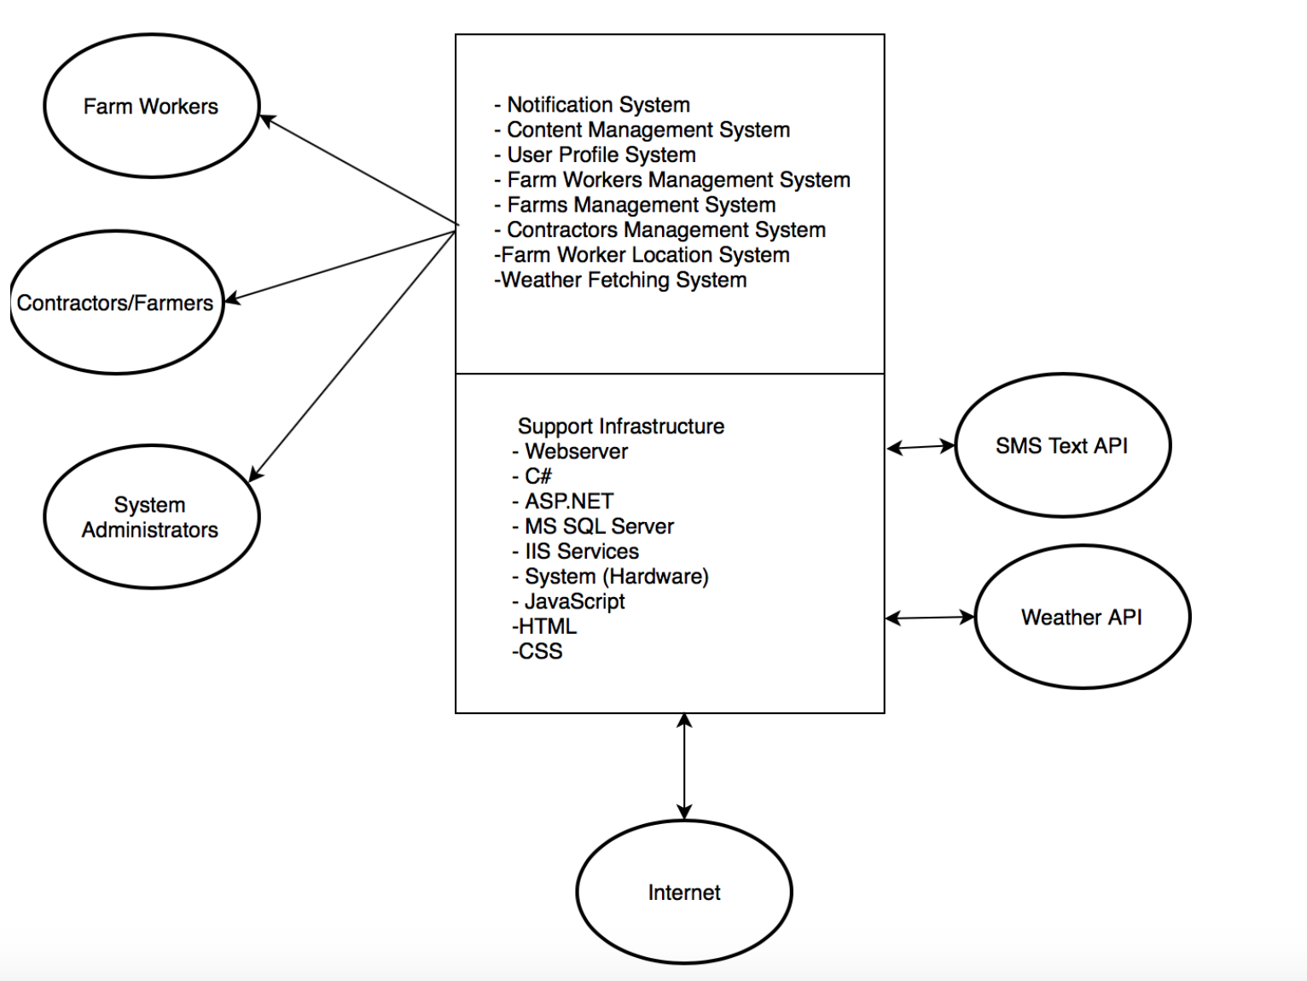

* Proposed New Operational Concept
  + Element Relationship Diagram (see example below)

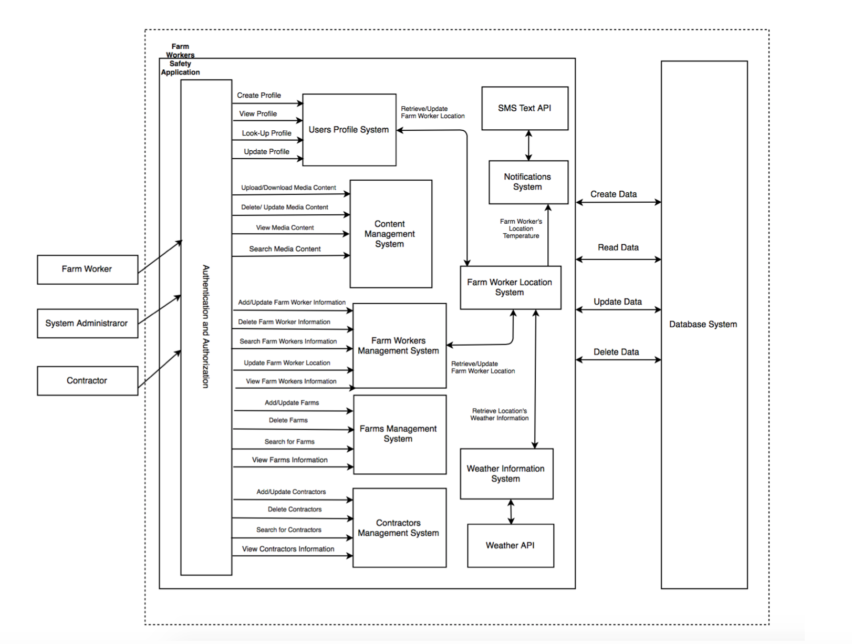

* + 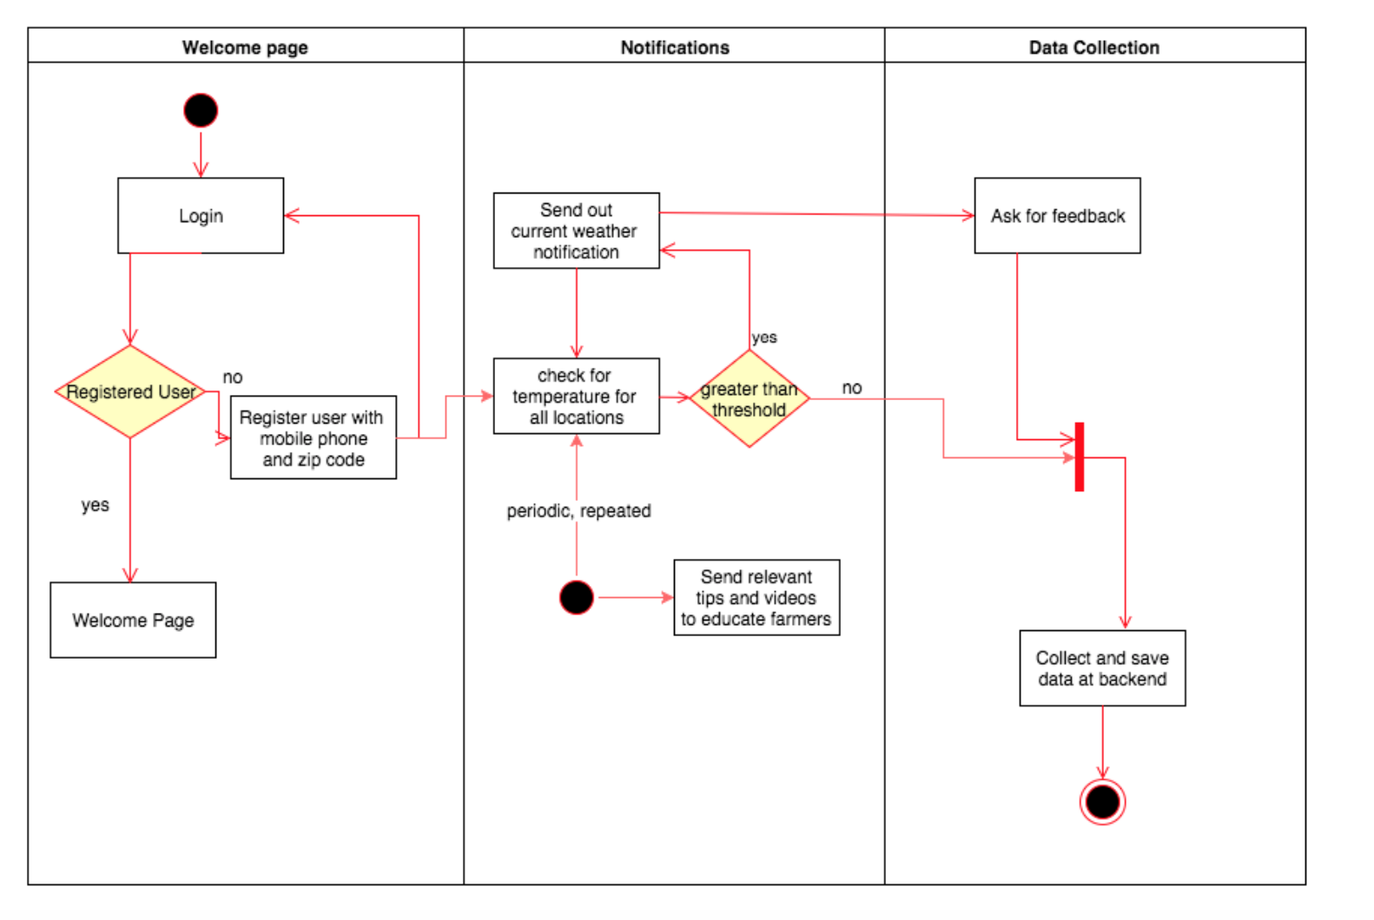Business Workflows